

**FINAL PROJECT**

***HANGMAN GAME***

GROUP MEMBERS:

SHAHZAD UMAR BAIG CSC-18F-120

URWA MAQSOOD CSC-18F-158

PROJECT REPORT OF

ORGANIZATION AND ASSEMBLY LANUAGE

*COURSE INSTRUCTOR: MISS SAHAR*

**Overview**

For the final project we will be making a hangman game. Hangman is a popular word game in which one player (the "chooser") chooses a secret word and another player (the "guesser") attempts to guess the word one letter at a time. If a guessed letter appears in the word, all instances of it are revealed. If not, the guesser loses a chance. If the guesser figures out the secret word before he or she runs out of chances, he or she wins. If not, the player who chose the word wins. Traditionally, chances are tracked using a stick figure drawing of a person being hanged from a gallows. The figure is drawn one body part at a time, and the guesser loses when the entire figure has been drawn.

**Scope:**

The scope of this project is to polish our skills and entertainment purpose.

**Flow Chart:**

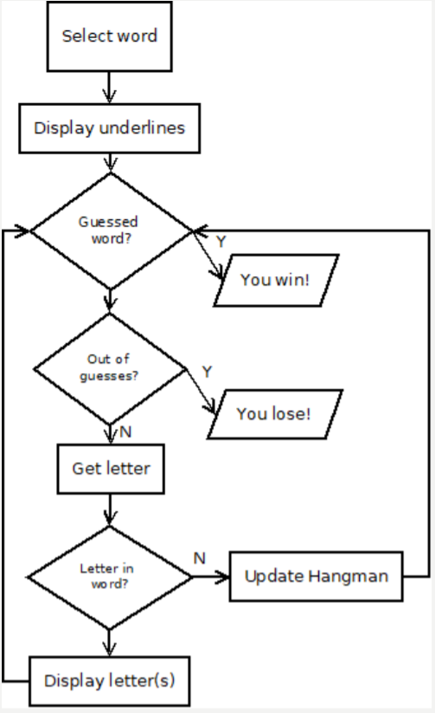

**Output:**

**Conclusion:**

In this project, we describe a realization of the game Hangman. Although the game is well known and built numerous times, our realization gives an exciting approach to a programming assignment made entirely in assembly programming language. This realization is especially interesting for educational purposes because it provides an exciting way to introduce students to assembly programming.